- Decimals

1. Without using mathematical tables or calculators, evaluate: (3 mks)
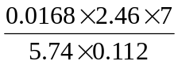
2. A two-digit number is such that the sum of the ones digit and the tens digit is 10. If the digits are reversed, the number formed exceeds the original number by 54. Find the number (3 mks)
3. Without using tables and calculators, evaluate
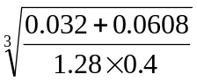 (3mks)
4. Use a calculator to find;
(a) 8754.3 x 53.84
(b) 0.8341 + 8.72
3
Hence find; 8754.3 x 53.84
0.8341 + 8.72
5. Express the recurring decimal below to a fraction 5.72 and leaving your answer in the form
ª/_{b} where a and b are whole numbers
6. Evaluate:- 0.38 x 0.23 x 2.7 without using tables or a calculator

7. Without using mathematical tables or calculator, evaluate:
0.084 x 1.32 x 3.5
2.87 x 0.056
Leaving the answer as a fraction in its simplest form.

8. Find without using a calculator, the value of :
12 0.0625 – 12.4 ÷ 0.4 x 3
¹/₈ of 2.56 + 8.68

